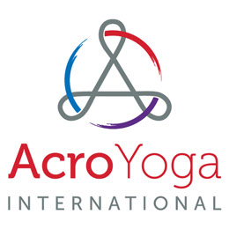
FOR IMMEDIATE RELEASE
AcroYoga at Piedmont Park Charity Event
KENNESAW, GA, July 10, 2017 – AcroYoga international will be holding a charity event to benefit “Yoga Gives Back” and spread awareness of AcroYoga as an activity and form of yoga. This event will take place on the International Day of Yoga June 21, 2018 and will host a number of food trucks, live entertainment, a keynote speaker, and more.
The AcroYoga at Piedmont Park Charity Event will take place at Piedmont Park, The Meadow, in downtown Atlanta, GA. The event will run from 10 a.m. to 4 p.m. and admission will be $20 a person with ticket sales opening May 1. All proceeds from ticket sales will benefit “Yoga Gives Back” to use toward alleviating poverty in India, in the country that gave birth to yoga, by building sustainable livelihoods for women and children through providing micro loan programs and education funds.
The event will feature a live performance by The Electrometers, whose music is featured in many of AcroYoga International’s online video lessons. Guest speaker, Jason Nemer, co-founder of the AcroYoga sport will hold an AcroYoga safety and training session 1:30 p.m. to 2 p.m. This will break off into a group beginner lesson for attendees lead by AcroYoga International trained instructors. Food trucks will be present throughout the event and options will include, Blenders and Bowls, Bon Me, Hola Arepa, TaKorean, The Cinnamon Snail, etc. AcroYoga International expects 4,000 attendees throughout the event period.
Founded in 2004 by Ryan Lee in Providence, RI, AcroYoga International is a nonprofit organization focused on growing the AcroYoga community around the world. AcroYoga is a mix of acrobatics, static poses and acrobatic flying involving two partners one as a base the other as a flyer. They provide pre-recorded video lessons by experienced Acro yogis for all skill levels; regularly distribute information on the health benefits of AcroYoga, and tips for safe practice. AcroYoga International has a determination to share the rewards that AcroYoga brings; the balance of strength with flexibility and the excitement of accomplished and controlled grace with a partner.
What is AcroYoga video: https://www.youtube.com/watch?v=nGJJinX1vGI
# # #
Contact:
Ryan Lee Atlanta 678-207-9821 nayreelx@yahoo.com

