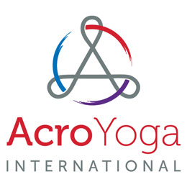
FOR IMMEDIATE RELEASE
AcroYoga International to Launch “Destination Acro” Contest
KENNESAW, GA, June 14, 2017 – AcroYoga International will be launching a photo contest on July 24 where participants will upload a picture of themselves doing AcroYoga poses in unique settings around the world. The winning participants will be awarded an all expense paid eight-day health, meditation, and AcroYoga retreat in Bali, Indonesia along with $1000 spending money.
The Destination Acro contest will be open entry and each picture will be judged on its ability to communicate a meaning, feeling, or story to the judges. The best five photos will be featured on the AcroYoga International website and social media platforms for the public to vote for a winning image to be announced November 1. The contest has been created to raise awareness of AcroYoga and the health benefits of practicing it. AcroYoga is a mix of acrobatics, static poses and acrobatic flying involving two partners one as a base and another as the flyer. “AcroYoga can shape the whole nature of the participant by enlightening physical, mental and spiritual traits,” said Carolina Calle, President of AcroYoga International. “Its athleticism, self-control, and awareness can improve one’s behavior, confidence, trust, and compassion.”
Founded in 2004 by Ryan Lee in Providence, RI, AcroYoga International is a nonprofit organization focused on growing the AcroYoga community around the world. AcroYoga is a mix of acrobatics, static poses and acrobatic flying involving two partners one as a base the other as a flyer. They provide pre-recorded video lessons by experienced Acro yogis for all skill levels; regularly distribute information on the health benefits of AcroYoga, and tips for safe practice. AcroYoga International has a determination to share the rewards that AcroYoga brings; the balance of strength with flexibility and the excitement of accomplished and controlled grace with a partner.
What is AcroYoga video: https://www.youtube.com/watch?v=nGJJinX1vGI
###
Contact:
Ryan Lee Atlanta 678-207-9821 nayreelx@yahoo.com

